**MENTAL HEALTH PREDICTOR USING AI & ML**

Mr. Ashish Kumar Rastogi, Assistant Professor CSE, Chandigarh University Gharuan,

Pratibha Ladha, UG Scholar CSE, Chandigarh University Gharuan, 18bcs6093@cuchd.in

Vaibhav Tripathi, UG Scholar CSE, Chandigarh University Gharuan, 18bcs6052@cuchd.in

Satyam Vibhu, UG Scholar CSE, Chandigarh University Gharuan, 18bcs6053@cuchd.in

Shawal Kumar, UG Scholar CSE, Chandigarh University Gharuan, 18bcs6066@cuchd.in

Ritika Lamba, UG Scholar CSE, Chandigarh University Gharuan, 18bcs6067@cuchd.in

***Abstract----Mental health problems are widespread and are an important medical problem. However, clinical diagnosis of mental health problems is expensive, time-consuming, and often extremely delayed, highlighting the need for new self-identification methods. Psychological and psychological research has suggested that the use of metaphors in texts is linked to the state of mental health. In this paper, we suggest how to automatically find metaphors in texts to predict various mental health problems, especially anxiety, depression, low self-esteem, empathy, fear of society, and infatuation. We are doing experiments on a compilation database collected for second language learners and the eRisk2017 database collected on Social Media. Test results show that our approach can help predict mental health problems for authors of the text, as well as ours. The algorithm works better than other advanced methods. In addition, we report the use of metaphors even in non-native areas. Languages ​​can be an indicator of a variety of mental health problems.***

**KEYWORDS: Mental Health, psychiatrists or counsellors, Teen Stress, Suicide, Sentiment Analysis, unemployment, age standardized suicide rates, Drug Use, Social Media Safety**

1. **INTRODUCTION**

Mental health problems have worsened. It not only endangers people's physical and mental health but also affect the development of the country and society. A WHO study (https://www.who.int/health-topics/mentalhealth) shows that about 13% of the world's population suffers from mental disorders, which cost the world economy one by one billions of dollars a year. Depression is one of the main causes of disability. Suicide is the second leading cause of death children aged 15-29. About 20% of children and adolescents in the world suffers from mental illness, as well as the highly educated a number of people are also suffering from depressive disorders their academic performance [1-3]. However, clinical diagnosis. Mental health problems are expensive, time-consuming, and frequent is too late, which highlights the need for the novel methods for diagnosing these conditions.

Metaphors are often used in human terms language [4 - 7]. It includes both grammar and psychological processes [8] and are a vague form of transmission emotions [9-11]. Personal feelings and attitude, which they are important in mental health, are often talked about and portrayed in metaphors suggests that the use of metaphors in texts may indicate attitude and mind as well as assisting in mental health to check. Psycholinguistic and psychological research has shown that the use of metaphors in the text is linked to the mind the health of their authors [12 - 16]. For example, patients with schizophrenia may use the figurative expression “time dishes” refers to watches and “handmade ”referred to gloves. In other words, the use of metaphors in the individual mental illness may be different for those who do not, which is can provide new opportunities to diagnose mental illness through metaphors as a diagnostic indicator. Although unclear what causes this deviation from the production of metaphor, neuroscience research provides some clues. Experts note that other mental illnesses such as schizophrenia are related to amygdala dysfunction, which is active and regulatory emotions [17]. Some studies suggest that it is a metaphor the texts are closely associated with the activation of the amygdala there are areas where direct speech [18]. With the development of artificial intelligence once various data processing technologies [19 - 25], efficiency modern medical diagnosis is always improving. Like an important part of artificial intelligence, natural language processing is widely used in issues related to mental health [26-28]. Shathi et al. [29] reviewed the use of machine learning in mental health: the four main areas of application, including diagnosis and diagnosis [30, 31]; prediction, treatment, and support; public health; research and treatment managers. The most common mental health conditions mentioned include depression, schizophrenia, and Alzheimer's disease.

Previous work has shown that it is possible using NLP techniques with various features extracted from them messages such as language, demographics, and behavioral factors to predict depression such as depression [32], suicide [33], and posttraumatic stress disorder [34]. However, few studies have involved the use of metaphor, a deep semantic aspect, as a means of discovery and predict mental health problems. Once immediately the explosion of social media applications such as Twitter and Facebook, there seems to be a significant increase in symbolic texts on a variety of topics, including products, services, community events, and issues affecting people's health. It seems to be an important and promising challenge for development metaphorical features to support identification as well prediction of mental health problems.

In this paper, we suggest the use of automatic acquisition metaphors in texts to predict various mental health problems which includes anxiety, depression, low self-esteem, empathy, social cohesion phobias, and anxiety. We named our Metaphor Sentiment Model (MSM) method and conducted experiments on a set of creative data we have created in a second language student articles and eRisk2017 database collected from Social Media. Our offerings are as follows.

(i) We propose a new method of identifying a few mental health problems by using language metaphors in texts as factors. For our own good information, we are the first to use the metaphor features to support the identification and prediction of mental health problems.

(ii) Test results indicate that our proposed method can help predict the mental health of the authors of the text and our algorithm provides efficiency, compared to standard methods.

(iii) Function indicates semantic content, in particular the use of metaphors in individual-produced texts, can help achieve six mental health problems. This seems to be a new result when used of metaphors even in non-native languages ​​can be used as an indicator of various mental health problems.

(iv) It contributes to the novel, is rare, and important. The database, which will be released to the public, includes articles for second language speakers and data on mental health problems of authors obtained from a psychological survey.

(v) Due to lack of appropriate work, inspection factors that affect mental health using calculation methods can help early detection and treatment of mental health as well related problems.

1. **RELATED WORK**

**2.1.** Mental Health in NLP. NLP techniques have been used to predict the state of human mental health, based on that written texts, such as those on Facebook, Twitter, etc., and can be used to obtain information on the user's attitude directly and effectively [35]. In recent years, experts have explored many different aspects data sets to assess background mental health a text. Nguyen et al. [36] used data from External Live Journal Post website to collect 38 k posts in mind sick community and 230 k posts from mentally healthy people societies predicting mental illness. They tried a variety of methods, including language and vocabulary questions count (LIWC), acquiring language, social, practical, rational, observant, biological, related, personal attention, and oral, emotional aspect (and supported LIWC) and the latest dirichlet (LDA) models, we have finally achieved 93% accuracy. Franco-Penya once Sanchez [37] built a tree structure based on n-grams feature and other integrated features and support vector machine (SVM) learning methods for designing separators in them find out the state of mental health at CLPsych2016 [38]. Cohan et al. [39] lexical features widely considered, context features, text data features, and text caption features on the same database, using SVM separators to complete the acquisition tasks. Ramiandrisoa et al. [40] tried a various aspects of the dictionary in another exploration activity CLEF 2018 Risk database [41], including word bag models, names of specific categories, and special word combinations, and convert text into vectors for classification. Weerasinghe et al. [42] The language investigated patterns that distinguish people with mental illness from the control group, which includes the word bag, word groups, part of the n-gram features of speech, and title models to understand the machine learning model.

In addition to the use of text and other user features, the rise of in-depth reading has provided new ways to find mental illness by text. Benton et al. [43] model many situations predict different levels of suicide risk as well creates a multi-activity learning framework (MTL) to meet the needs of different jobs. Trotzek et al. [44] The original text was translated at vectors then completed the division function using a convolutional neural network to predict mental health user status. Sekulic and Strube [45] used the class attention network and analyzed relevant phrases with the attitude of social media users through testing weights of attention to model name level. Multimodal thinking it is also used in mental health research [46, 47]. A multimodal method that contains text-sharing analysis as well as visual and audio data and its relation to mental health in addition to text analysis.

**2.2.** Data sets. As discussed above, metaphors they are associated with attitude and perception. From a metaphor involves mental processes, it is possible to screen and monitor mood and touch regardless language fluency. We think so metaphor is an important aspect of text in mental health discovery among language users, which includes both native and who speak a second language. We collected data for both various sources to confirm our thinking and expand the reliability of our test in this relationship study between the use of metaphors and the state of mental health.

**2.3.** Student Structure and Mental Health. Collect English compilation data from Chinese with English knowledge college students who speak English as a second language. We and collected mental health data from these students using a psychological survey. First, apply it online and offline campus advertisements for recruiting 164 young college students participants who pass a 4th grade English exam for national college students in China, meaning they are indigenous. Chinese is also fluent in English. Before participating, all participants provided a consent form proving their ownership willingness to participate in the study. Participants provided their personal details in the questionnaire then has written a composition with 500 or more English words inside for two hours. The formation of the had two parts: describe their previous life experience and be introduced their future plans, including their good future, thoughts in life, aimed at their future lives, and plans for victory bars. Content has given us a deeper understanding of it attitudes [48], essential for diagnosis of mental health problems.

After writing their composition, students were needed complete a checklist of two mental health questions levels of mental health problems. The first level involved serious mental health problems, especially critical minds such as hallucinations, suicidal ideation, and suicidal tendencies. In our study, few students had first grade problems. The second level involved common sense problems such as anxiety, depression, depression, empathy, and social phobias. Psychological problems were assessed in the basis of a standard school of assessment indicators. Specifically, participants were screened for mental health problems when their points in certain indicators exceed the normal results. We could not enter data for 8 students because we could not align their mental problems with vague clues from them mental health data. Active mental health data for the remaining 156 students are presented in Table 1. Meanwhile, extract data from students without mental health problems that you can use as controls to analyze the differences in them using metaphor and symbolism in texts.

The data collection process took four months again resulted in a total of 156 songs with 130,044 lyrics from 156 students (aged 18-23, which means = 19.06 years, SD = 0.19, males = 86, and females = 70), and mental health data obtained from a list of psychological questions. Th then data is kept secure and stored numerically identifying features, i.e., consent forms and questionnaires.

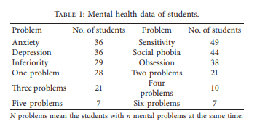

**2.4.** ERisk2017 data. The eRisk2017 pre-stress risk detection function [49] provides a database containing posting content and comments from Reddit. Th function of identified 135 Reddit users with depression and 752 Reddit users without getting frustrated with their posts and comments. The number of words per Reddit user varies from 10 to 2,000. The individual Reddit user database contains individual identification, writing data, text title, type of writing, and writing content. Page [50] details the construction of ERisk data. They you first selected Reddit on multiple social networks the media also collected post diagnostic posts by direct search (such as being diagnosed with depression). Posts are checked in person to identify users they are found to be really depressed. The eye-collected patients’ text records published on Reddit over time. We compiled the content of each Reddit user in chronological order with current research.

1. **METHODOLOGY**

Our work flow is shown in Figure 1. The metaphor is connected to mental health problems as described above. Take us out metaphors from texts and the element designed for the metaphor is set to predicting various mental health problems. Our way too consider emotional aspects in sample texts such as these the feature has been widely used in mental health research [14, 44, 51, 52]. We have used metaphors and emotional aspects in our Metaphor-Sentiment Model (MSM) to predict the mind health problem. Feature release algorithm is short summarized in algorithm 1, and more details will be presented below.

3.1. Metaphor Feature Background. Based on a metaphor features, consider the following (Algorithm 1, Step 1):

(i) The percentage of tokens marked as a metaphor by automatic metaphor identification method

(ii) The opportunities for a sentence containing a metaphor

We also considered the metaphorical emotions expressed in a sentence that corresponds to the feelings of the sentence. First, SentiStrength (http://sentistrength.wlv.ac.uk/) became used to analyze the overall mood of a sentence. SentiStrength Analysis reveals two points of emotional strength: negative (points −1 to − 5) and positive (points 1 to 5). The sum of the two values ​​is the sum of the emotional points of herd. Emotional score 0 is defined as neutral. Next, Student problem number The problem is the number of students Anxiety 36 Sensitivity 49 Depression 36 Social phobia 44 Floor 29 Self-esteem 38 One problem 28 Two problems 21 The Ree 21 problems Four problems 10 Five problems 7 Six problems 7 N problems mean students with mental disorders at the same time. Health engineering journal 3 determine metaphorical emotions using three direct Feature values ​​(Algorithm 1, Step 3):

(i) The number of metaphors that feel good (effects of positive emotions)

(ii) The number of negative metaphors (side effects)

(iii) The a measure of the emotional effects of all metaphors

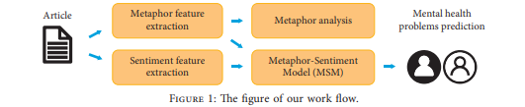

On our way, the metaphors were automatically seen using a strategy that has shown excellent performance activities to identify the metaphorical level of tokens to date [53]. The default metaphor identification system consists of four steps: (1) trains word embedding in the Wikipedia dump site based on Continuous Bag of Words (CBOW) and SkipGram models to find input and output vectors for all models. voice; (2) chooses the words found to examine the metaphor and separate the words found in a given sentence; (3) removes all possible similar names and direct hypernyms, which includes its variability, of the derived word from WordNet, and adds them to the word w candidate, containing all the senses of the acquired name; and (4) chooses the most appropriate word for w ∗, representing the real thing the meaning of the word derived from a given sentence, from The candidate name is set w, using the following formula:



(1)

where k ∈ w, vk is the input vector for CBOW or SkipGram for the word k, and vcontext means average of all input vectors in context words. This fits very well the name has the highest similarity of cosine and context words. Finally calculate the similarity of the word obtained and the most appropriate word using the output vectors in order measure the difference of meaning between a given word and context. The acquired name is labeled as a metaphor when the match value is less than that given threshold. Practical uses find all the words of content in a sentence. Th a detailed process is introduced in algorithm 2.

We trained and tested the identification algorithm in a data template developed by Mohammad [10] that contains 210 metaphorical sentences whose names have been found are defined manually by at least 70% agreement. We select the same number of direct sentences from thousands of direct sentences in the database. A very good metaphor detection performance had an accuracy of 0.635, remember 0.821, and the F1 value of 0.716 with a limit of 0.5, i.e. is similar to the diagnostic function reported by Mao.

To test the performance of our metaphor and our data set, we selected ten randomly songs from each of the seven related groups in six mental health problems and healthy controls. All in all, seventy songs were analyzed. The metaphorical functionality using student database was- accuracy of 0.632, memory 0.935, and F1 value of 0.754.

Figure 2 shows examples of metaphors found by an automatic metaphorical recognition method from the reader design data set (a-c) and eRisk2017 data set (d-f). Th e sentences correspond to two words from different domains: for for example, a source name marked as symbolic, such as broken, and a target word like a dream. However, this A metaphorical token identification algorithm is generated some errors as it points to a location-based metaphor information surrounding the acquired name and cannot detect a consistent consistency of success. For example, in a sentence I finally got up on my own, the algorithm by mistake marked the word itself as a metaphor.

3.2. Emotional Feature Domain. The set of emotional feature include an average of five sizes for all of them words; ratio of positive sentences, negative sentences, and neutral sentences; emotional rating of sentences, and the amount of emotional fluctuations in each other article, which gives ten specific features in total.

We used SentiStrength to get emotional points sentences in texts as above, to calculate I negative sentence, negative sentence, and neutral sentence; sentence sentence of the article; the effect of individual mood swings title (Algorithm 1, Step 2).

The average number of sentences in each article was the same is calculated to determine the emotional value of the article using the following formula:



(2)

where E stands for the central emotional value of the text, Si represents the emotional points of the sentence i, and n is the number of sentences in the text. And flexibility points are obtained by extracting two emotional points consecutive sentences in the article and take them completely number. We used the scale as the value of mood swings. The following formula is determined



(3)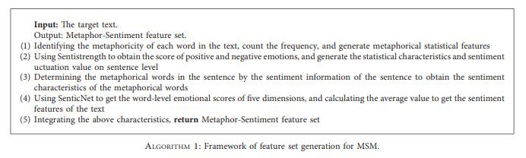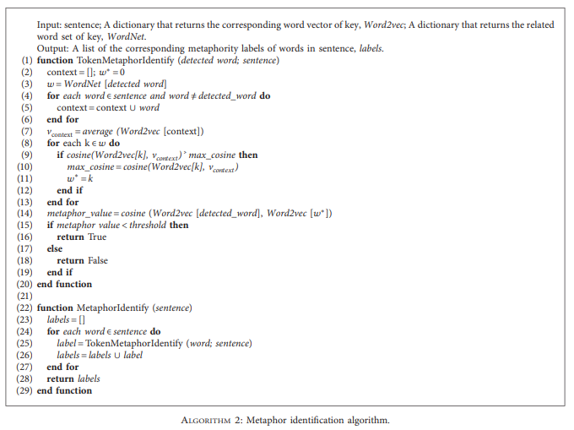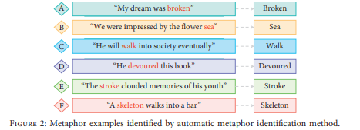

where F stands for the mood fluctuations of text.

Five-dimensional scores (fun numbers, attention, sensitivity, suitability, and polarity) were obtained using SenticNet (http://www.sentic.net) (Algorithm 1, Step 4). five-dimensional ratings of all names were present taken as an indication of the emotion of the article. The ratings were the same Listed as an example of sweet prices:



(4)

where P represents the ratio of sweetness values ​​as well Wi represents the sweetness of the word i. Attention values, sensitivity values, eligibility values, and the polarity values ​​are calculated in the same way.

1. **METAPHOR ANALYSIS**

We analyzed the use of the metaphor for six mental disorders at once health controls based on automatically identified outcome, including examples of identified metaphors and statistical analysis.

Table 2 shows examples of the most commonly used methods metaphors for each of the seven mental health groups. To to show the features of each group, we do not include metaphorical, very common words common to all mental health groups, such as salary, high, and limit. The same metaphor was often used differently how about those in the mentally healthy group in comparison those in groups with a mental health problem, as shown in the following examples:

*Ex1. Teachers are always trying their best to meet the needs of the students.*

*Ex2. We always encounter various difficulties along the way read.*

The sentence in the first example is taken from a student formation in a healthy control group and expresses a good feeling, while the second example was taken from the naming of a student in the depression group and expresses negative emotions.

We read the sentiments of the text and the effect of the metaphor on Student Composition Data mathematical information shown in Table 3.

Average emotions mean the central points of emotion of the whole text and meta emotion is a measure of sentence by sentence metaphor. People in the sympathetic group have very high emotions points and the obsession group is very low. Meta sensation in total it is 0.05 less than avg. emotion, indicating that, in Student Setup Data Set, students are more likely to express negative emotions and explain sad things metaphor, for example, sentences A and C in Figure 2.

*Ex3. My dream was a dream*

*Ex4. You will finally enter the community*

Previous reveals the lost state of a broken dream, and the latter is used to illustrate the unstable nature of growth high and enters the community. They both use the metaphor for express negative emotions.

To better understand the features of using metaphor for each mental disorder, we listed students as sick or not sick all psychological problem and metaphorical features analyzed between the two groups. The histograms in Figure 3 show the state of the various symbols of each metaphor health problem. We found that sentence opportunities containing metaphor was higher among students with low or social phobia than students without these minds problems (t= 1.775, p <0.1; t= 1.695, p <0.1). Students with Social phobia was more prone to using metaphors through negative emotions than students without social phobia (t = 1.978, p <0.05). In addition, students with obsession had it significantly lower scores on average metaphorical emotions than non-obsessive readers (t= −2.060, p <0.05) very diverse index of songs by four students Mental health problems were likely to be punished with metaphor. Students with mental health problems were on top eigenvalues ​​are more flexible than those in the healthy group.

1. **EXPERIMENTS**

We compared the predicted performance of MSM once based on the eRisk2017 database [49] and the second language speaker news database, and we explored metaphorical feature with common text features used in foundation. Each of the six mental health issues in The data set for the second language speaker is subject to divorce the task of dividing into two categories. We plan to ensure efficiency of metaphorical features in obtaining a variety of concepts health problems, and we used the same Metaphor-Sentiment a feature set for each task of predicting a mental health problem. The parameters of the different models will be obtained differently psychological problems to deal with metaphorical features.

We have used the Synthetic Minority Oversampling Technique (SMOTE) to reduce inequality between positive and negative bad samples in the Student Design database. SMOTE The algorithm analyzes small samples and produces new ones samples in the database. Th e a certain process: (1) randomlyselect sample x for small and count Euclidean the distance between it and other samples at this stage; (2) randomly select a sample xn from the nearest neighbours k x is listed in the previous step; (3) according to the following formula, a new sample is formed and added to it small sample set; (4) repeat the steps above until the appropriate sample size is obtained.



(5)

**5.1. Foundation.** The proposed prediction method [44] was selected as the basis as it has shown excellent performance in ERisk2017 and eRisk2018. The use two methods in ERisk2017 data for finding people suffering from depression. One approach involved retrospect using features issued with four-word mathematical tools — LIWC (http://liwc.wpengine.com/), NRC Emotion Lexicon(http://[www.saifmohammad.com/WebPages/NRC-Emotion-Lexicon](http://www.saifmohammad.com/WebPages/NRC-Emotion-Lexicon). htm), Opinion Lexicon (http://www.cs.uic.edu/∼liub/FBS/ opinion-lexicon-English.rar), and VADER Sentiment.

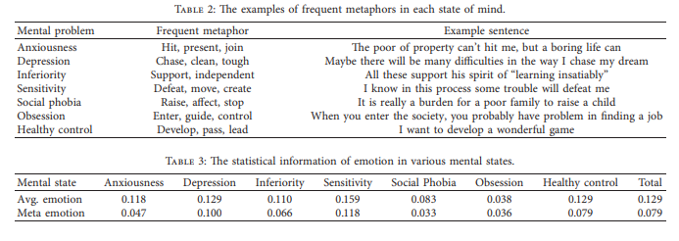

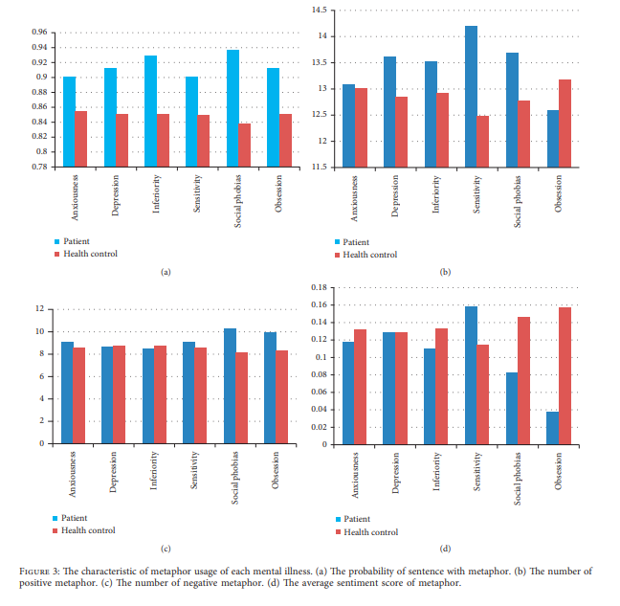

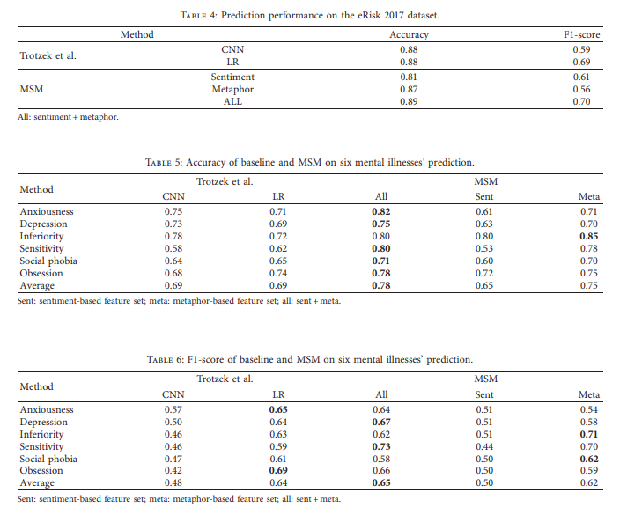

Lexicon (<http://www.nltk.org/_modules/nltk/sentiment/vader>. html). These tools scan text input to calculate frequency of words in a variety of contexts, such as the general frequency of motivation — words used to express good emotion. The word output output statistics can be a deep learning-based approach that uses convolutional neural network (CNN). We redo both methods again compared our method of two data sets.

5.2. PredictionMethod. We used a metaphor-based feature set and the emotion-based element set to form the Metaphor-Sentiment Model (MSM) for predicting mental health status. We compared the performance of three standard class dividers: equipment retreat, SVM, and neural network. The neural network produce the best results as the relationship between the factors and mental health problems may be indirect. To prevent the neural network model from becoming overcrowded in training a set of low-level student data, add L2 familiarity, stopping layer, and how to stop early in the model. At that time, the number of layers and layer nodes hidden in the network is determined by testing. 10 times cross confirmation used in testing to confirm model performance.

The neural network in this paper is built using Keras (https://github.com/keras-team/keras), a fourlayer, a fully integrated neural network that includes single inputs layer, two hidden layers, and one exit layer. The installation layer it was a vector that combined the elements of metaphor with emotional features extracted from the data. The two hidden layers layered with output sizes of 100 and 50, respectively. The input layer and the two hidden layers use straightforward integrated units (CReLU) in the activation function. We add a drop-off layer between two hidden layers by quit 0.4 rating to prevent rust. The output layer used by Softmax an activation function, which conveys a common sense dual output functions and vectors.

5.3. Performance Testing. The eRisk2017 The database contains divided into a training set and a test set [49]. We checked

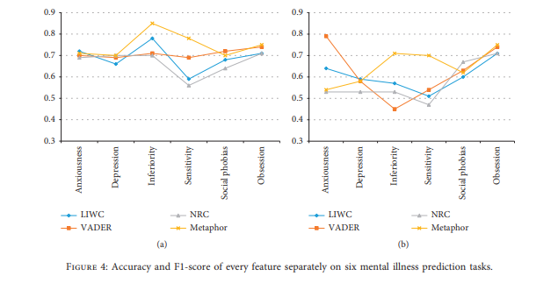

MSM uses emotion-based feature set, metaphor-based feature set, or both and compares results. and those who use the basic method. The results are displayed in Table 4. Our screening method works better than these two basic methods for both accuracy and F1-score. Ku moreover, the results show that feature based on the metaphor

sets are helpful in detecting stress. Results show the height of our forecast method compared to standard methods such as those used our foundation.

We used 10 times cross confirmation to separate Composition data collected for second-language students to evaluate the performance of MSM predictions compared to the basic methods. The results are displayed in Tables 5 and 6.

Table 5 compares the accuracy of the two bases methods and each of our six predictive methods mental health problems. The results show that MSM has achieved the highest accuracy, with the highest accuracy among them all six mental health problems that were much higher than that base (Fisher's direct test: p <0.05), especially about sensitivity predictor function (Fisher's direct test: p <0.005). The metaphor-based feature set plays an important role in MSM and performs well beyond emotions a feature set for all the guessing activities of a mental health team. It obtained the highest accuracy of prediction, corresponding to a large metaphorical difference use between lower and upper students low, as discussed above.

Considering the unequal samples, we also made a computer F1-score of all activities for predicting mental health problems. The results are shown in Table 6. Overall, using all sets of features, our method has shown very high predictive performance of six mental health problems on average F1- The result. The F1-score improvement was significant with respect for empathetic students (Fisher's direct test: p <0.05). The basic method of disposal of acquired assets the same results as our overall approach. Based on metaphor the feature set in our path showed high F1 scores predicting minimum and social phobia.

To further evaluate the functionality of the metaphorical element sets, compare the image-based feature set and the emotion-based feature with three common text features issued by LIWC, NRC Emotion Lexicon, and VADER Sentiment Lexicon is also used in retardation the basic method. The line charts shown in Figure 4 available accuracy and F1-score performance for each feature separately to predict six mental health problems using a neural network classifier. The results show that sets of metaphorical features work better in predicting lowness and sensitivity than other features of the text as well equally effective in predicting other mental health problems.

To our knowledge, we are the first to show predictions of six mental disorders — anxiety, depression, empathy, empathy, social fears, and infatuation — exploitation metaphors found automatically in texts. We used image-based feature sets and emotion-based feature sets for predicting these mental health problems using a combination Database produced by second-language and ERisk2017 data collected on Social Media. Our results show that the proposed method can predict the mind the health status of the authors of the text, as well as our algorithm it works well compared to other high-quality methods. We also analyzed differences in the use of metaphor between students with different mental health problems and examined the efficiency of metaphorical sets compared to other texts features in predicting the state of mental health from the creative database of second language speakers.

Our work illustrates the value of symbolic text features of predicting mental health problems. The test results remind us of the importance of metaphor, as a deep, complex, and psychological aspect of mental health identification, which usually focuses on shallow language features. Importantly, we show that the metaphor is speculative and to non-native speakers. We also contribute to the database of the novel, which is rare, and important, inclusive Articles of second language speakers and psychological data of authors health problems found in psychological research, which we will release it publicly. We hope this paper will inspire young people ideas for identifying and predicting mental health situation with textual analysis and led to the development of default methods for this purpose.

**DATA AVAILBILITY**

The data used to support the research findings are as follows is available from the corresponding author upon request.

**CONFLICTS OF INTEREST**

The authors declare that they have no conflicts of interest.

**ACKNOWLEDGEMENTS**

This work was supported by Mr. Ashish Kumar Rastogi, Assistant Professor CSE, Chandigarh University Gharuan.

**REFERENCES**

[1] K. Levecque, F. Anseel, A. De Beuckelaer, J. Van der Heyden, and L. Gisle, “Work organization and mental health problems in phD students,” Research Policy, vol. 46, no. 4, pp. 868–879, 2017.

[2] R. Bruffaerts, P. Mortier, G. Kiekens et al., “Mental health problems in college freshmen: prevalence and academic functioning,” Journal of Affective Disorders, vol. 225, pp. 97– 103, 2018.

[3] T. M. Evans, L. Bira, J. B. Gastelum, L. T. Weiss, and N. L. Vanderford, “Evidence for a mental health crisis in graduate education,” Nature Biotechnology, vol. 36, no. 3, pp. 282–284, 2018.

[4] L. Cameron, Metaphor in Educational Discourse, A&C Black, London, UK, 2003.

[5] E. Shutova and S. Teufel, “Metaphor corpus annotated for source-target domain mappings,” in Proceedings of the International Conference on Language Resources and Evaluation, LREC, vol. 2, Citeseer, Valletta, Malta, May 2010.

[6] D. Zhang, H. Lin, X. Liu, H. Zhang, and S. Zhang, “Combining the attention network and semantic representation for Chinese verb metaphor identification,” IEEE Access, vol. 7, pp. 137103–137110, 2019.

[7] P. H. Thibodeau, T. Matlock, and S. J. Flusberg, “The role of metaphor in communication and thought,” Language and Linguistics Compass, vol. 13, no. 5, Article ID e12327, 2019.

[8] G. Lakoff and M. Johnson, “Conceptual metaphor in everyday language,” >e Journal of Philosophy, vol. 77, no. 8, pp. 453–486, 1980.

[9] Z. Kovecses, “Anger: its language, conceptualization, and physiology in the light of cross-cultural evidence,” Language and the Cognitive Construal of the World, Cambridge University, Cambridge, UK, pp. 181–196, 1995.

[10] S. Mohammad, E. Shutova, and P. Turney, “Metaphor as a medium for emotion: an empirical study,” in Proceedings of the Fifth Joint Conference on Lexical And Computational Semantics, pp. 23–33, Berlin, Germany, August 2016.

[11] V. Dankers, M. Rei, M. Lewis, and E. Shutova, “Modelling the interplay of metaphor and emotion through multitask learning,” in Proceedings of the 2019 Conference on Empirical Methods in Natural Language Processing And the 9th International Joint Conference on Natural Language Processing (EMNLP-IJCNLP), pp. 2218–2229, Association of Computational Linguistics, Hong Kong, China, November 2019.

[12] R. M. Billow, J. Rossman, N. Lewis, D. Goldman, and C. Raps, “Observing expressive and deviant language in schizophrenia,” Metaphor and Symbol, vol. 12, no. 3, pp. 205–216, 1997.

[13] B. Elvev˚ag, K. Helsen, M. De Hert, K. Sweers, and G. Storms, “Metaphor interpretation and use: a window into semantics in schizophrenia,” Schizophrenia Research, vol. 133, no. 1, pp. 205–211, 2011.

[14] E. D. Gutierrez, G. A. Cecchi, C. Corcoran, and P. Corlett, “Using automated metaphor identification to aid in detection and prediction of first episode schizophrenia,” in Proceedings of the 2017 Conference on Empirical Methods in Natural Language Processing, pp. 2923–2930, Copenhagen, Denmark, September 2017.

[15] J. Llewellyn-Beardsley, S. Rennick-Egglestone, F. Callard et al., “Characteristics of mental health recovery narratives: systematic review and narrative synthesis,” PLoS One, vol. 14, pp. 1–31, 2019.

[16] D. Magana, “Cultural competence and metaphor in mental healthcare interactions: a linguistic perspective,” Patient Education and Counseling, vol. 102, no. 12, pp. 2192–2198, 2019.

[17] R. Rasetti, V. S. Mattay, L. M. Wiedholz et al., “Evidence that altered amygdala activity in schizophrenia is related to clinical state and not genetic risk,” American Journal of Psychiatry, vol. 166, no. 2, pp. 216–225, 2009.

[18] F. M. M. Citron and A. E. Goldberg, “Metaphorical sentences are more emotionally engaging than their literal counterparts,” Journal of Cognitive Neuroscience, vol. 26, no. 11, pp. 2585–2595, 2014.

[19] X. Li, M. Zhao, M. Zeng et al., “Hardware Impaired Ambient Backscatter Noma Systems: reliability and security,” IEEE Transactions on Communications, vol. 69, no. 4, pp. 2723– 2736, 2021.

[20] L. Sun, L. Wan, and X. Wang, “Learning-based resource allocation strategy for industrial iot in uav-enabled mec systems,” IEEE Transactions on Industrial Informatics, vol. 17, no. 7––, pp. 5031–5040, 2020.

[21] L. Sun, J. Wang, and B. Lin, “Task allocation strategy for mecenabled iiots via bayesian network based evolutionary computation,” IEEE Transactions on Industrial Informatics, vol. 17, no. 5–, pp. 3441–3449, 2020.

[22] H. Wang, L. Xu, Z. Yan, and T. A. Gulliver, “Low complexity mimo-fbmc sparse channel parameter estimation for industrial big data communications,” IEEE Transactions on Industrial Informatics, vol. 17, no. 5–, pp. 3422–3430, 2020.

[23] L. Wan, L. Sun, K. Liu, X. Wang, Q. Lin, and T. Zhu, “Autonomous vehicle source enumeration exploiting non-cooperative UAV in software defined internet of vehicles,” IEEE Transactions on Intelligent Transportation Systems, pp.1–13, 2020.

[24] L. Wan, Y. Sun, L. Sun, Z. Ning, and J. J. P. C. Rodrigues, “Deep learning based autonomous vehicle super resolution doa estimation for safety driving,” IEEE Transactions on Intelligent Transportation Systems, 2020.

[25] L. Xu, H. Wang, and T. A. Gulliver, “Outage probability performance analysis and prediction for mobile iov networks based on ics-bp neural network,” IEEE Internet of >ings Journal, vol. 8, no. 5–, pp. 3524–3533, 2020.

[26] M. Conway and D. O’Connor, “Social media, big data, and mental health: current advances and ethical implications,” Current Opinion in Psychology, vol. 9, pp. 77–82, 2016.

[27] S. Graham, C. Depp, E. E. Lee et al., “Artificial intelligence for mental health and mental illnesses: an overview,” Current Psychiatry Reports, vol. 21, no. 11, p. 116, 2019.

[28] S. D’Alfonso, “Ai in mental health,” Current Opinion in Psychology, vol. 36, pp. 112–117, 2020.

[29] A. B. R. Shatte, D. M. Hutchinson, and S. J. Teague, “Machine learning in mental health: a scoping review of methods and applications,” Psychological Medicine, vol. 49, no. 09, pp. 1426–1448, 2019.

[30] S. Mulyana, S. Hartati, R. Wardoyo, and Subandi, “A processing model using natural language processing (nlp) for narrative text of medical record for producing symptoms of mental disorders,” in 2019 Fourth International Conference on Informatics and Computing (ICIC), pp. 1–6, Semarang, Indonesia, October 2019.

[31] M. Levis, C. Leonard Westgate, J. Gui, B. V. Watts, and B. Shiner, “Natural language processing of clinical mental health notes may add predictive value to existing suicide risk models,” Psychological Medicine, pp. 1–10, 2020.

[32] H. A. Schwartz, J. Eichstaedt, M. Kern et al., “Towards assessing changes in degree of depression through facebook,” in Proceedings of the Workshop on Computational Linguistics and Clinical Psychology: From Linguistic Signal to Clinical Reality, pp. 118–125, University of Cambridge, Cambridge, UK, October 2014.

[33] C. Homan, R. Johar, T. Liu, M. Lytle, V. Silenzio, and C. O. Alm, “Toward macro-insights for suicide prevention: analyzing fine-grained distress at scale,” in Proceedings of the Workshop on Computational Linguistics And Clinical Psychology: From Linguistic Signal to Clinical Reality, pp. 107– 117, Baltimore, MA, USA, June 2014.

[34] G. Coppersmith, M. Dredze, and C. Harman, “Quantifying mental health signals in twitter,” in Proceedings of the Workshop on Computational Linguistics and Clinical Psychology: From Linguistic Signal to Clinical Reality, pp. 51–60, Baltimore, MA, USA, June 2014.

[35] R. A. Calvo, D. N. Milne, M. S. Hussain, and H. Christensen, “Natural language processing in mental health applications using non-clinical texts,” Natural Language Engineering, vol. 23, no. 5, pp. 649–685, 2017.

[36] T. Nguyen, D. Phung, B. Dao, S. Venkatesh, and M. Berk, “Affective and content analysis of online depression communities,” IEEE Transactions on Affective Computing, vol. 5, no. 3, pp. 217–226, 2014.

[37] H.-H. Franco-Penya and L. M. Sanchez, “Text-based experiments for predicting mental health emergencies in online web forum posts,” in Proceedings of the >ird Workshop on Computational Linguistics And Clinical Psychology, pp. 193– 197, San Diego, CA, USA, January 2016.

[38] D. N. Milne, G. Pink, B. Hachey, and R. A. Calvo, “Clpsych 2016 shared task: triaging content in online peer-support forums,” in Proceedings of the >ird Workshop on Computational Linguistics And Clinical Psychology, pp. 118–127, San Diego, CA, USA, June 2016.

[39] A. Cohan, S. Young, and N. Goharian, “Triaging mental health forum posts,” in Proceedings of the >ird Workshop on Computational Linguistics And Clinical Psychology, pp. 143– 147, San Diego, CA, USA, June 2016.

[40] F. Ramiandrisoa, J. Mothe, F. Benamara, and V. Moriceau, “IRIT at eRisk 2018,” in Proceedings of the 9th Conference And Labs of the Evaluation Forum, Living Labs (CLEF 2018), pp. 1–12, Avignon, France, September 2018.

[41] D. E. Losada, F. Crestani, and J. Parapar, “Overview of erisk: early risk prediction on the internet,” in International Conference of the Cross-Language Evaluation Forum for European Languages, pp. 343–361, Springer, Berlin, Germany, 2018.

[42] J. Weerasinghe, K. Morales, and R. Greenstadt, ““Because... I was told... So much”: linguistic indicators of mental health status on twitter,” Proceedings on Privacy Enhancing Technologies, vol. 2019, no. 4, pp. 152–171, 2019.

[43] A. Benton, M. Mitchell, and D. Hovy, “Multitask learning for mental health conditions with limited social media data,” in Proceedings of the 15th Conference of the European Chapter of the Association for Computational Linguistics: Volume 1, Long Papers, pp. 152–162, Valencia, Spain, April 2017.

[44] M. Trotzek, S. Koitka, and C. M. Friedrich, “Utilizing neural networks and linguistic metadata for early detection of depression indications in text sequences,” 2018, http://arxiv.org/ abs/1804.07000.

[45] I. Sekulic and M. Strube, “Adapting deep learning methods for mental health prediction on social media,” in Proceedings of the 5th Workshop on Noisy User-Generated Text (W-NUT 2019), Hong Kong, China, November 2019.

[46] L. Tavabi, “Multimodal machine learning for interactive mental health therapy,” in 2019 International Conference on Multimodal Interaction, ICMI’19, pp. 453–456, Association for Computing Machinery, New York, NY, USA), October 2019.

[47] Z. Xu, V. P´erez-Rosas, and R. Mihalcea, “Inferring social media users’ mental health status from multimodal information,” in Proceedings of the 12th Language Resources and Evaluation Conference, pp. 6292–6299, European Language Resources Association, Marseille, France, May 2020.

[48] J. B. Hirsh and J. B. Peterson, “Personality and language use in selfnarratives,” Journal of Research in Personality, vol. 43, no. 3, pp. 524–527.

[49] D. E. Losada, F. Crestani, and J. Parapar, “Erisk 2017: clef lab on early risk prediction on the internet: experimental foundations,” in Proceedings of the International Conference of the Cross-Language Evaluation Forum for European Languages, pp. 346–360, Springer, Berlin, Germany, August 2017.

[50] D. E. Losada and F. Crestani, “A test collection for research on depression and language use,” in Proceedings of the International Conference of the Cross-Language Evaluation Forum for European Languages, pp. 28–39, Springer, Berlin, Germany, August 2016.

[51] J. P. Pestian, P. Matykiewicz, M. Linn-Gust et al., “Sentiment analysis of suicide notes: a shared task,” Biomedical Informatics Insights, vol. 5, pp. 1–6, 2012.

[52] S. Gohil, S. Vuik, and A. Darzi, “Sentiment analysis of health care tweets: review of the methods used,” JMIR Public Health and Surveillance, vol. 4, no. 2, p. e43, 2018.

[53] R. Mao, C. Lin, and F. Guerin, “Word embedding and wordnet based metaphor identification and interpretation,” in Proceedings of the 56th Annual Meeting of the Association for Computational Linguistics (Volume 1: Long Papers), pp. 1222–1231, Melbourne, Australia, July 2018.